

V 1.2
June 2026
XStep Design Specification
SMPL: Top-Off Tank Details

Table of Contents
1 Purpose 3
2 Overview 3
3 Reasons for developing 5
4 Authorization 5
5 Assumptions/ Dependencies 5
6 Validation Checks 5
7 XStep Layout Design 6
8 Function Module(s) 6
9 Pseudocode 8
10 Configuration Specification 11
11 Test Scenarios 12
12 Revision History 14

Purpose
This document outlines the design, along with the configuration specifications for the XStep “SMPL: Top-Off Tank Details”.

Overview
The SMPL: Top-Off Tank Details XStep facilitates the entry of top-off solution details when applicable during buffer preparation. The operator is prompted to indicate whether a top-off is required.
The XStep contains two main input parameters:
- IV_HEADER - This can be changed in SiMPL MBR to display specific header text for the XStep
- IV_INSTR - This can be changed in SiMPL MBR to display a specific set of instructions for the XStep that will be displayed below the header
- IV_OB_TY_T – This can be authored in SiMPL MBR to indicate which type of equipment should be usable during the execution of this XStep. Currently, this parameter value is defaulted to “2000”, for tanks.
- IV_SIGN – This can be changed in SiMPL MBR to author standalone signatures as part of the xstep.
The XStep is an optional XStep, thus the following rules apply:
- If “Yes” is selected, all the fields in the xstep become active.
- If “No” is selected, all the fields in the xstep become inactive, not allowing any data capturing.
This information ensures accurate tracking and integration of top-off solution data into the overall batch record.
The operator executes the “Select Top Off Tank” button:
- Select Top Off Tank - Function Button
The button is linked to the function module ZSMPL_FM_GET_ASSIGNED_EQUI_EBR. This module validates the equipment ID against Equipment Master data and performs the following operations:
- “Top Off Tank ID” - Input
- “Top Off Tank Description” - Output
The operator enters the PO Number for the Primary and Previous Solutions which will auto-populate the Part Number and Batch Number fields.
- “PO Number” - Input
- “Part Number” - Output
- “Batch Number” - Output
- “Primary Solution Expiry Date” - Output
The function module ZSMPL_FM_GET_PO_PRODUCT_INFO retrieves the part numbers and the batch numbers for the relevant solutions, as well as the primary solution’s expiry date. Additionally, the function module validates that the entered PO number’s part number matches the current PO’s part number, and that the entered PO’s batch has not yet expired.
The Planned Quantity (kg) auto-populates with the Order Quantity amount of the PO.
- “Planned Quantity (kg)” - Output

Next the operator inputs values for the current tank weight:
- “Current Tank Weight (kg)” - Input

A calculation function triggers to determine the Top-Off Batch Size (kg), using the formula: Planned Quantity - Current Tank Weight (LV_PLD_QTY - LV_TANK_WT). The Current Tank Weight will be consumed against the order for the entered quantity via the process message Z_PICONS.
The result of this calculation populates into the following field:
- “Top-Off Batch Size (kg)” - Output
The new Top-Off Batch Size is passed to component weigh-out steps to re-calculate the required quantities. The steps affected are SMPL: Material Weighing and SMPL: Initial Water Addition.
Functional Design
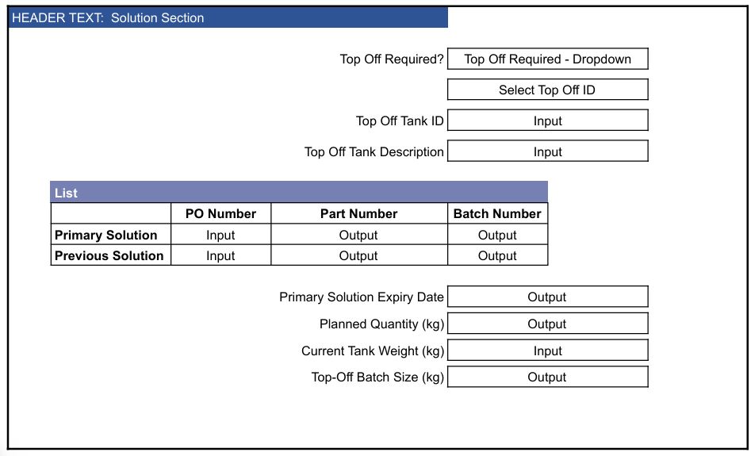

Reasons for developing
This XStep is being developed to ensure consistent, accurate, and traceable documentation of top-off solution details during buffer preparation. The step guides the operator through a structured decision and data entry process, ensuring that required information - such as tank identifiers, batch numbers, and quantities - is captured only when relevant.
Automating the retrieval of the batch number via a function module minimizes manual errors and improves data integrity. Additionally, calculating the batch size based on planned and actual tank weight ensures precision in batch tracking.

Authorization
N/A

Assumptions/ Dependencies
 | Assumption
1 | Operator signing signature fields is an approved operator in the system with the correct access configuration
2 | The function modules are available and return the required details.
3 | The function module can successfully pull the data into the output fields
4 | The calculation is based on the unit of measure being the same for the input fields

Validation Checks
Error Handling
Error | Action
Operator Signature rejected due to an incorrect username or password | Operator accepts error message and re-enter the correct username and password
Primary Solution Part Number mismatches current PO part number | Deviation occurs to indicate that products do not match
Primary Solution Batch number has expired | Operators accepts error message and signs with username & password to confirm that Primary Solution PO batch has expired
Top-Off Batch Size (kg) calculation is incorrect | Check that the batch size calculation is not negative

XStep Layout Design
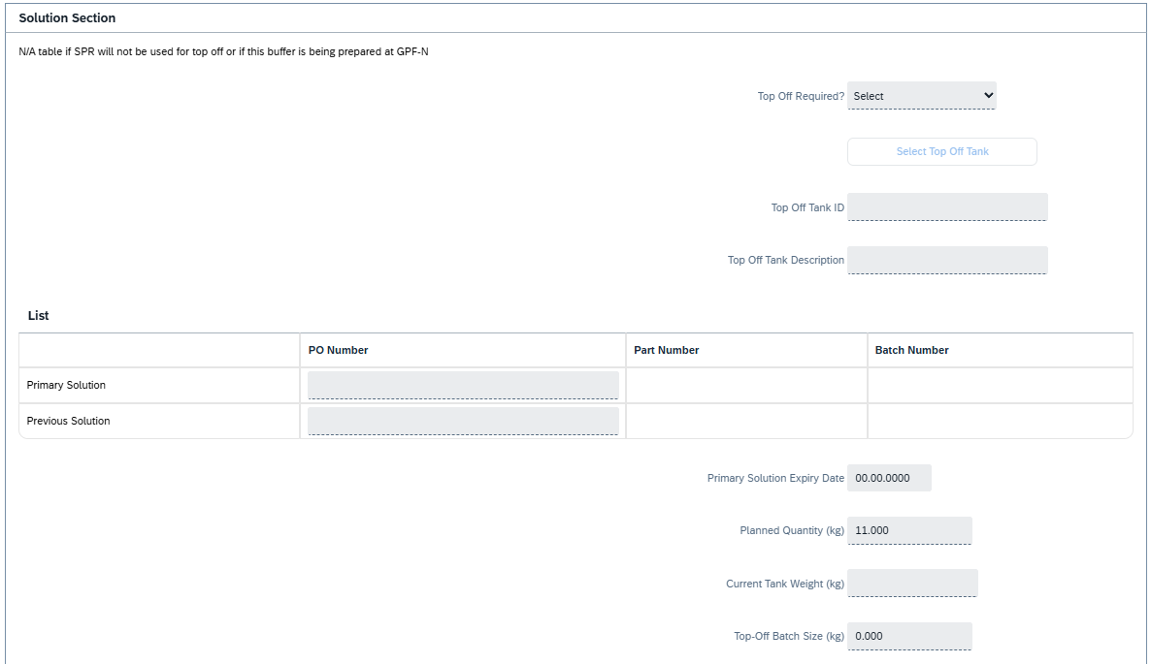

Function Module(s)
Function: /SMPL/PPPI_FM_GET_BATCH_NO
Import Parameters:
Parameter Name | Associated Type | Short Text
IV_PO_NR | AUFNR | Order Number

Export Parameters:
Parameter Name | Associated Type | Short Text
EV_BATCH_NR | CHARG_D | Batch Number

Function: /SMPL/PPPI_FM_INITIAL_ACTIVE
Import Parameters:
Parameter Name | Associated Type | Short Text
IV_ACTIVE | CHAR1 | N/A

Export Parameters:
Parameter Name | Associated Type | Short Text
EV_ACTIVE | CHAR1 | N/A

Function: /SMPL/MBR_DEP_CHECK_ACTIVE
Import Parameters:
Parameter Name | Associated Type | Short Text
IM_CONTROL_RECIPE | POC_DOCID | N/A
IM_PHASE | VORNR
IM_AUFNR | AUFNR
IM_STEP_UUID | /SMPL/MBR_SOG_UUID
IM_PLANT | WERKS_D

Export Parameters:
Parameter Name | Associated Type | Short Text
EV_ACTIVE | CHAR1 | N/A

Exceptions:
Exception | Short Text
CONTROL_RECIPE_INITIAL

Pseudocode
Function: /SMPL/PPPI_FM_GET_BATCH_NO
1. Database Query
a. Execute a single-row SELECT query on table AFPO (Order Item Data)
b. Search for the record where AUFNR = input process order number (IV_PO_NR)
c. Retrieve the CHARG field (batch number) into a local variable (lv_batch_nr)
2. Data Assignment
a. Assign the retrieved batch number (lv_batch_nr) to the export parameter EV_BATCH_NR
3. Function Completion
a. The function ends after successfully retrieving and assigning the batch number
Additional Notes:
- Purpose: Retrieves the batch number associated with a given process order
- Assumptions:
The process order exists in the AFPO table
A batch number (CHARG) is assigned to the order
- Error Handling:
No error handling is implemented for:
- Process orders not found in AFPO
- Missing or initial batch numbers
- Performance:
Executes quickly due to the use of a single-row SELECT SINGLE query
- Usage Context:
Typically used when a batch number needs to be retrieved for downstream processing in PI Sheets, weighing steps, or material validation routines

Function: /SMPL/PPPI_FM_INITIAL_ACTIVE
1. Initialization
a. Input parameter IV_ACTIVE is optionally provided by the calling logic.
b. Constants gc_yes, gc_no, and gc_inside_range are assumed to be defined globally in the context of the function module.
2. Active Flag Evaluation
a. The function checks if the input value IV_ACTIVE falls within the expected valid range, represented by gc_inside_range.
b. Based on the result:
- If the input value is not equal to gc_inside_range, the XStep is marked as inactive by setting EV_ACTIVE = gc_no.
- If the input value is equal to gc_inside_range, the XStep is marked as active by setting EV_ACTIVE = gc_yes.
3. Output Assignment
a. The evaluated result is returned in the EV_ACTIVE export parameter for use by the calling logic (e.g., XStep configuration, PI sheet rendering).
Additional Notes
- This is a simple normalization function that abstracts how activation flags are interpreted for PPPI XSteps
- The use of constants (gc_yes, gc_no, and gc_inside_range) allows the logic to be aligned with broader application settings or standards.
- Helpful in scenarios where input values may vary but need to result in consistent "active" or "inactive" behavior.
- Input is optional, so defaulting behavior can be configured outside this function.
- This function improves clarity and consistency in determining whether an XStep should be active when rendered in the PI Sheet.
Function: /SMPL/MBR_DEP_CHECK_ACTIVE
1. Initialization
a. Input parameters provide context for determining whether an MBR (Manufacturing Batch Record) step can be activated:
- IM_CONTROL_RECIPE (POC_DOCID) – Control recipe ID identifying the batch instruction.
- IM_PHASE (VORNR) (Optional) – Operation or phase within the process order.
- IM_AUFNR (AUFNR) (Optional) – Process order number associated with the step.
- IM_STEP_UUID (/SMPL/MBR_SOG_UUID) – Unique step identifier (SOG).
- IM_PLANT (WERKS_D) – Plant code for process context.
b. The function first validates that IM_CONTROL_RECIPE is not initial.
- If it is initial, the exception CONTROL_RECIPE_INITIAL is raised.
c. Internal data is initialized:
- lt_ord_sigs: Internal table for storing order signature data from /SMPL/MBR_OR_SIG.
- ls_step_dep: Work area for step dependency data.
- Routine LOAD_INTERNAL_DATA is called to populate internal buffers (g_ord_data-t_ord_deps) using IM_AUFNR, IM_CONTROL_RECIPE, and IM_STEP_UUID.
2. Signature Data Retrieval
a. The function retrieves signature records for the process order from database table /SMPL/MBR_OR_SIG.
b. Selected fields include: AUFNR, SOG_UUID, TYPE, CREATED_DATE, CREATED_TIME, DEST_NAME, SIGN_ID, SIGN_DATE, and SIGN_TIME.
c. Only signatures related to the specified order (AUFNR = IM_AUFNR) are selected.
d. These records are stored in the internal table lt_ord_sigs for later evaluation.
3. Dependency Evaluation
a. The function loops through dependencies in g_ord_data-t_ord_deps where:
- TARGET_UUID = IM_STEP_UUID, and
- DEP_RULE is either gc_perform_before_start_rule or gc_verify_before_start_rule.
b. For each dependency record:
- If the rule is PERFORM BEFORE START, it checks whether the prerequisite step (PREREQ_UUID) has a pending perform signature (gc_perform_signature) with SIGN_ID = abap_false.
- If the rule is VERIFY BEFORE START, it checks whether the prerequisite step (PREREQ_UUID) has a pending verify signature (gc_verify_signature) with SIGN_ID = abap_false.
c. If an incomplete signature is found, the step is marked inactive (EV_ACTIVE = gc_step_inactive).
d. If all prerequisite signatures are complete, the step is marked active (EV_ACTIVE = gc_step_active).
4. Output Assignment
a. The evaluated activation status is returned in the export parameter EV_ACTIVE.
- gc_step_active – All prerequisite steps are completed; the current step can start.
- gc_step_inactive – At least one prerequisite step is incomplete; the current step remains blocked.
Additional Notes
This function determines whether a dependent step in a Manufacturing Batch Record is eligible to start based on the completion of prerequisite steps.
Key Features:
- Evaluates Perform Before Start and Verify Before Start dependency rules.
- Dynamically validates signature data from /SMPL/MBR_OR_SIG.
- Integrates with existing MBR dependency structures via global table g_ord_data-t_ord_deps.
Error Handling:
- Raises CONTROL_RECIPE_INITIAL if the control recipe input is missing.
- Handles empty dependency or signature data without runtime errors.
Dependencies:
- Tables: /SMPL/MBR_OR_SIG (Signatures), g_ord_data-t_ord_deps (Step Dependencies).
- Constants: gc_perform_before_start_rule, gc_verify_before_start_rule, gc_perform_signature, gc_verify_signature, gc_step_active, gc_step_inactive.
- Routine: LOAD_INTERNAL_DATA for initializing order context.
Assumptions:
- All prerequisite steps are recorded in the dependency table.
- Signature records are current and synchronized with MBR step progression.
- Activation status is recalculated each time the function is called to reflect live signature data.

Configuration Specification
Goods Issue Configuration (Z_PICONS)
The process message Z_PICONS is used to communicate goods issue data from the XStep execution to the backend system. This message handles material consumption postings (typically movement type 261) for the components used in production. During execution, the XStep collects and transfers relevant component data such as material number, batch, issued quantity, unit of measure, storage location, and any applicable scrap quantities. The message is triggered upon confirmation of each goods issue table row and ensures that the component consumption is correctly reflected in the process order. All generated process messages are captured in transaction CO54, where they can be monitored and processed/sent. Configuration of Z_PICONS allows flexible mapping of input parameters and supports integration with both standard and custom logic for inventory updates and traceability.

Test Scenarios
# | Scenario | Expected Result | Actual Result | Pass/ Fail
1 | Create and Release a Process Order with the pre-configured SiMPL Master Recipe and the relevant Production Version | Process Order created and Released containing SMPL: Top-Off Tank Details | Process Order created and Released containing SMPL: Top-Off Tank Details
2 | Open the EBR, and navigate to SMPL: Top-Off Tank Details | The EBR for the selected Process Order and Control Recipe opens successfully without any errors and the SMPL: Top-Off Tank Details is visible | The EBR for the selected Process Order and Control Recipe opens successfully without any errors and the SMPL: Top-Off Tank Details is visible
3 | The value entered in parameter IV_HEADER and parameter IV_INSTR in SiMPL MBR appears correctly in the XStep header | Header and instruction text are displayed as authored in SiMPL MBR | Header and instruction text are displayed correctly.
4 | “No” is selected in the dropdown input | Dropdown selection of “No” is accepted. The entire step is deactivated. | Dropdown selection of “No” is accepted. The entire step is activated.
5 | “Yes” is selected from the dropdown input | The entire step is activated on “Yes” | The entire step is activated on “Yes”
6 | The operator selects a tank using the “Select Top Off Tank” button. | The equipment details are populated in the “Top-Off Tank ID” and “Top Off Tank Description” fields. | The equipment details are populated in the “Top-Off Tank ID” and “Top Off Tank Description” fields.
7 | The operator inputs the PO Number for the “Primary Solution” and the “Previous Solution”. | Input values are accepted. The Primary Solution and Previous Solution part numbers and batch numbers are automatically populated in the Part No, and Batch No fields. The Previous solution Expiry Date is populated in the “Primary Solution Expiry Date” field. | Input values are accepted. The Primary Solution and Previous Solution part numbers and batch numbers are automatically populated in the Part No, and Batch No fields. The Previous solution Expiry Date is populated in the “Primary Solution Expiry Date” field.
8 | The operator inputs an invalid PO Number for the “Primary Solution” or “Previous Solution”. | Validation function is triggered to perform checks on Part Numbers, Batches, and Expiry Date. | Deviation is triggered to perform checks on Part Numbers, Batches, and Expiry Date.
9 | Enter the “Current Tank Weight”. | Input values are accepted. | Input values are accepted
10 | Verify that the Top-Off Batch Size is correctly calculated and cannot be a negative number. | Top-Off Batch Size is correctly calculated. | Top-Off Batch Size is correctly calculated.
11 | Enter a username in the “Performed By” field then enter the password in the pop-up window. | Signature is accepted | Signature is accepted
12 | Enter a username in the “Witnessed By” field then enter the password in the pop-up window. | Signature is accepted | Signature is accepted

Revision History
Version No. | Description | Author | Date
1.1 | Initial Document (Functional Requirements and Technical Specifications) | Karla Uys and Frieda van der Merwe | 23-07-2025
1.2 | The following Technical Spec sections added to spec: Function Module(s), and Pseudocode. | James Church | 19-06-2026

